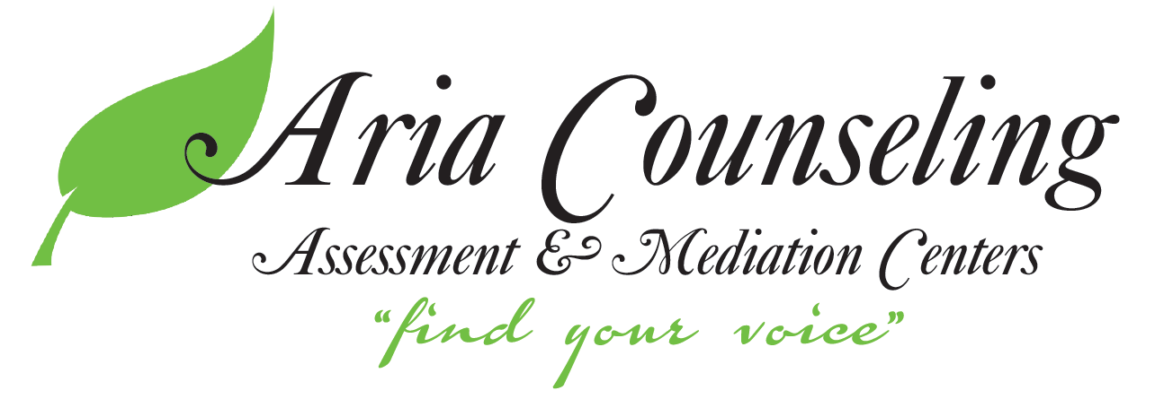
(763) 572-2612
admin@ariacounselingmn.com
www.ariacounselingmn.com

7260 University Avenue NE Suite 235
Fridley, MN 55432

3249 Hennepin Ave South Suite 144
Minneapolis, MN 55408

ACKNOWLEDGEMENT FORM

I have received the Notice of Privacy Practices and I have been provided with an opportunity to review it.
Client Name (Please Print): ____________________________________________

Date of Birth: _______________________________________________________

__________________________________________________________________
Signature Date

Guarantor (Guardian), If Applicable: ____________________________________

Date of Birth: _______________________________________________________

__________________________________________________________________
Signature Date

