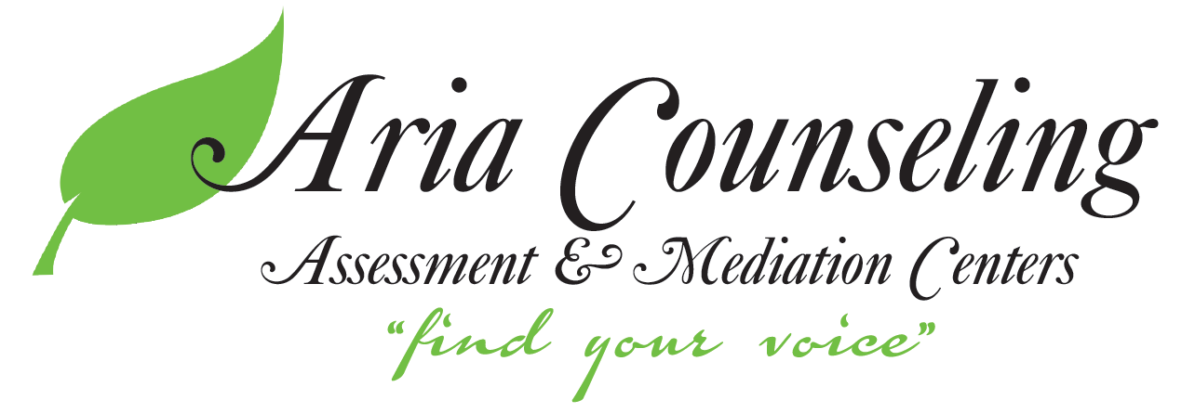
Crisis Resource Information

IF THIS IS A LIFE-THREATENING EMERGENCY, CALL 911.

Phone Lines
National Suicide Hotline – Call 988 to be connected with the Suicide and Crisis Lifeline 24/7, 365 days a year.
Crisis Text Line – Text “MN” to 741741 to be connected to a volunteer crisis counselor 24/7, 365 days a year.
United Way – Call 211 or (651) 291-0211 to speak with a resource navigator about services available to you in your area.
Minnesota Warmline – Call (651) 288-0400 between 9 AM and 9 PM 7 days a week to be connected with one of Mental Health Minnesota’s peer support specialists.
Peer Support Connection Warmline of Minnesota – Call (844) 739-6369 between 9 PM and 5 AM 7 days a week to be connected with a Wellness in the Woods peer support specialist.

Anoka County
Mobile Crisis Team – (763) 755-3801
Children’s Mental Health Line – (763) 324-1430

Hennepin County
Community Outreach for Psychiatric Emergencies (Mobile Crisis Team) – (612) 596-1223
Child Crisis Services – (612) 348-2233

Ramsey County
Adult Mental Health Urgent Care – (651) 266-7900
Children’s Crisis Response – (651) 266-7878

Community Mental Health Resources
Walk-In Counseling Center – Free drop-in counseling with virtual, phone, and in-person options. In-person services offered from 1-3 PM on Mondays, Wednesdays, and Fridays. Virtual services offered 1-3 PM on Mondays, Wednesdays, and Fridays and 5:30-7:30 PM on Monday-Thursday. See walkin.org for Zoom links and phone numbers.
People, Inc. Crisis Beds – Call (651) 774-0011, ext. 2 to be connected to People, Inc.’s Adult Residential Crisis Services. Locations include Nancy Page Residence in Minneapolis, Diane Ahrens in St. Paul, and Steiner Kelting in Chaska.

